Name: | ___________________________________________________ |  |  |  | Date: ___________
 | Year 8  Investigation 4, 2013  Topic – Venn Diagrams  Take home component
Date out: |  | Week ____ Date ___________ | Date Due: | Week ____ Date ___________
Take home component: |  | 5 Marks | In-class component weighting: | 5% of the year.
AIM: In this assessment, you will be investigating Venn Diagram
Some History for Data Handling
There are lots of technical terms you might need to be able to use to do with this part of maths. It is associated with a part of maths called statistics. Benjamin D'israeli, a famous Prime Minister, once said, "There are three types of lies: Lies, damned lies and statistics." He said this because you can often use statistics to put forward your ideas and people will assume they are right because of the power of numbers. The moral is: be careful when people start quoting statistics at you.
A major advocate of statistics was Florence Nightingale. She actually invented the pie chart in order to persuade the government of the importance of health care and medical facilities.
Did you know that Venn Diagrams were first thought of by John Venn in July 1880. Carroll diagrams were invented by Lewis Carroll who also wrote Alice in Wonderland.
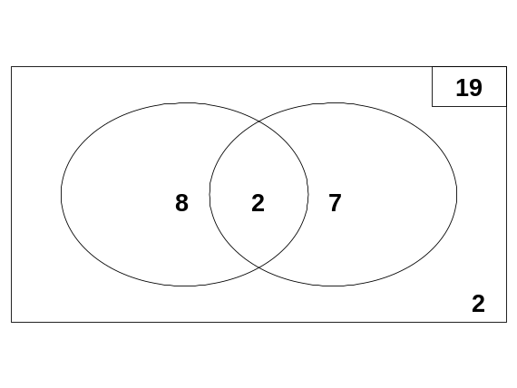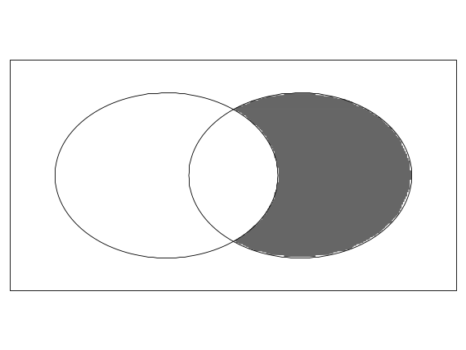

Sorting Characters

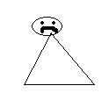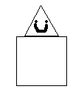

Look at the figures above

Cut them out and sort them placing them in the Venn diagram on the next page based on the shapes used to create them.

Triangles

Squares

Reading Venn Diagrams

A class of students were surveyed about whether they liked the Dockers or the Eagles. The results were placed into the Venn diagram below.
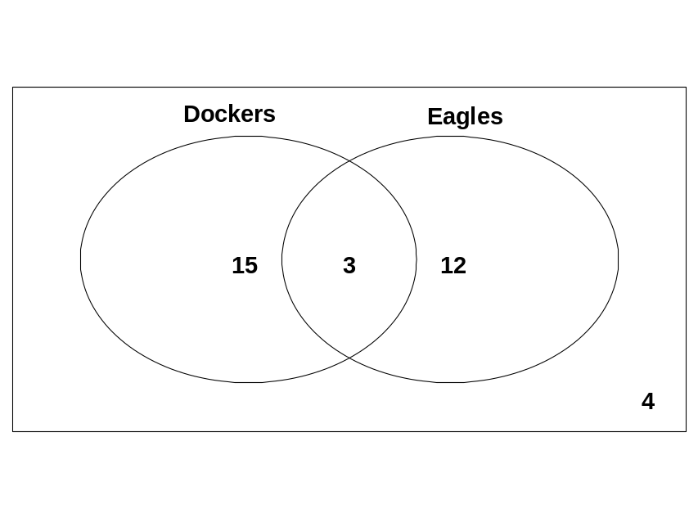

Answer the following questions with the information from the diagram

- How many students were surveyed? _______

- How many students liked both the Dockers and the Eagles?_______

- How Many students like the Dockers? _______

- How many students like the Eagles? _______

- How many students only liked the Dockers? _______

- How many students only liked the Eagles? _______

- How many students did not like the Dockers or the Eagles? _______

Shading Venn Diagrams

Shade the section of people who like Pizza  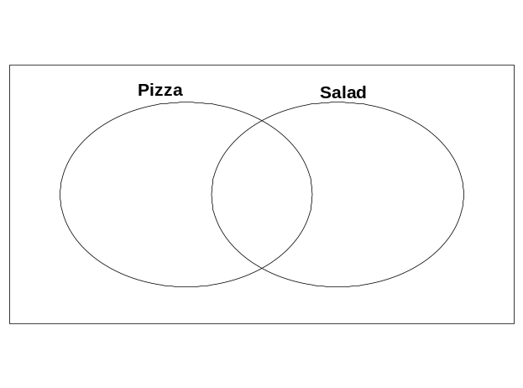 | Shade the section for people who only like salad
Shade the section for people who don’t like salad or pizza | Shade the section for people who like both salad and pizza  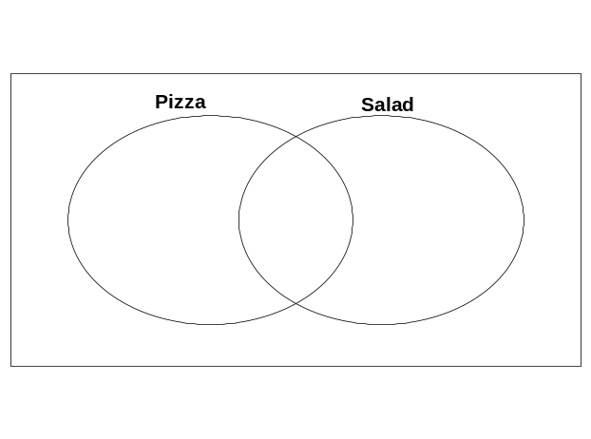

Answers to the Sorting Characters activity
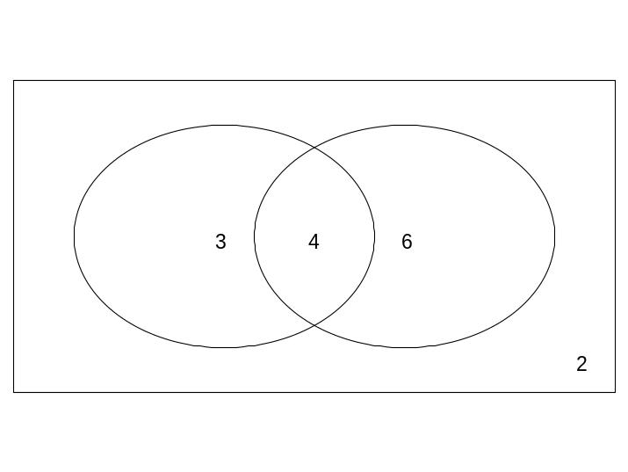You should have the following:
4 in the middle section (the overlap) ones with Squares and triangles
2 in the box but outside the circles (the pentagon and circle ones)
3 in the triangle only section
6 in the squares only section

Check this
If you didn’t get it correct check with a friend, then with the teacher

Answers to the Dockers and Eagles Questions
- 34
- 3
- 18
- 15
- 15
- 12
- 4
Answers to Shading
Shade the section of people who like Pizza  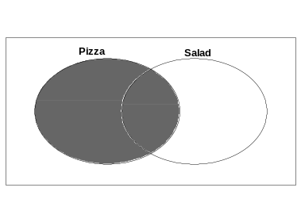 | Shade the section for people who only like salad  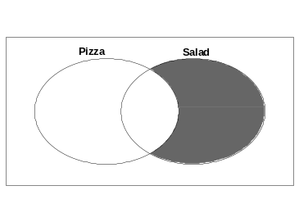
Shade the section for people who don’t like salad or pizza  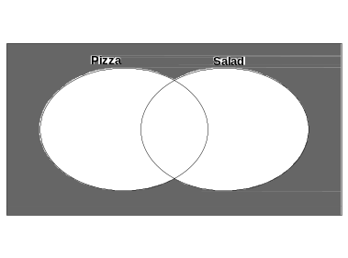 | Shade the section for people who like both salad and pizza  